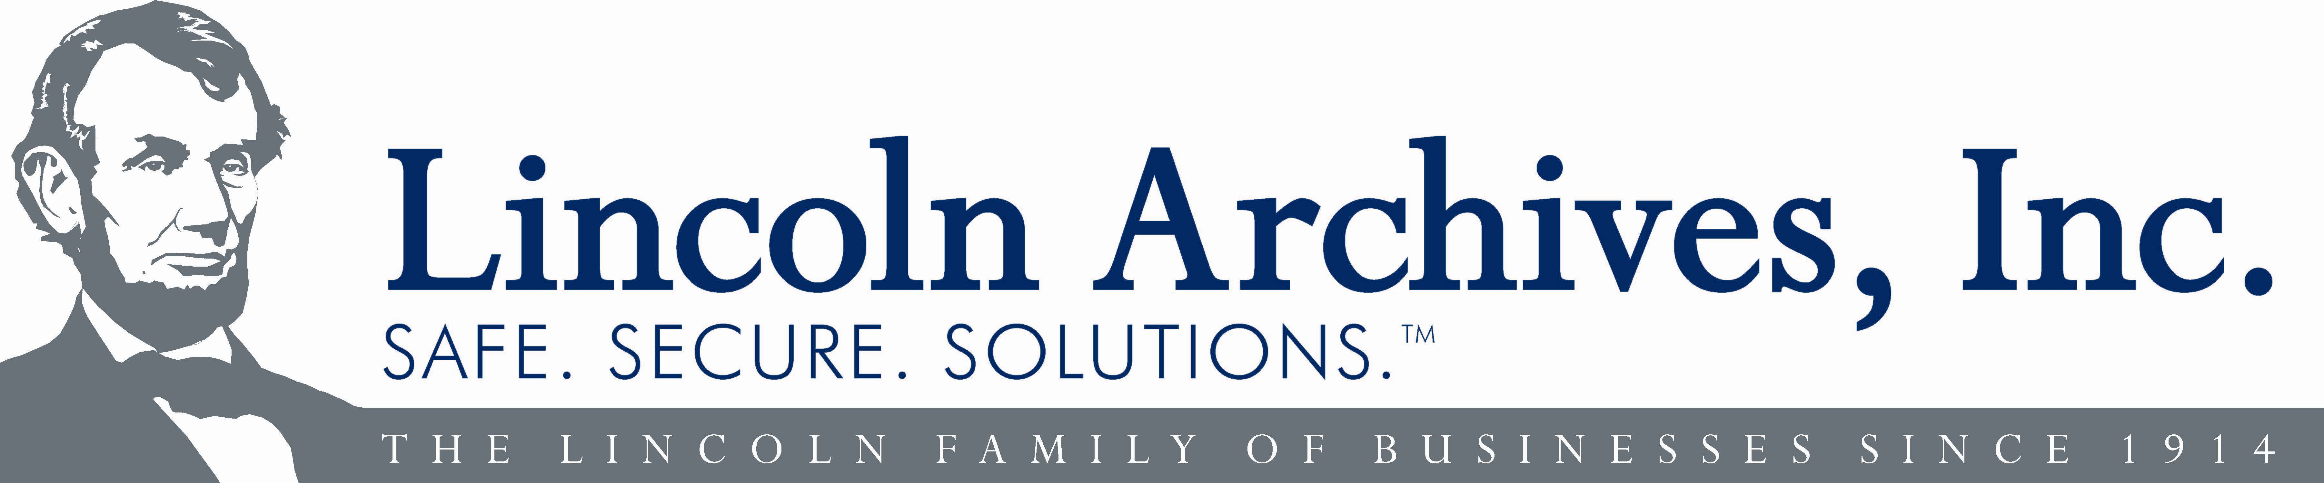

FOR IMMEDIATE RELEASE:

Lincoln Archives Receives Rare Industry Certification

Buffalo, New York 5.23.11 – Lincoln Archives, a company focusing on information security, is the only business in the Buffalo Niagara Region with not one, but two team members designated as a Certified Secure Destruction Specialist (CSDS).
William Palisano, President and John Miller, Operations Manager of Lincoln Archives have recently passed the CSDS examination and have been nationally recognized for joining the worldwide body of professionals known by NAID (The National Association for Information Destruction).
This is a special honor for Lincoln Archives since Lincoln now has the only two people in the entire region to have this singular certification. In fact, less than 100 people in the United States have received this designation.
According to Dustin McKissen, NAID Deputy Chief Executive Officer, “Now-a-days, companies that are interested in generating a higher degree of data security are looking for specialized organizations, who possess this type of certification. Establishing CSDS credentials as part of a company’s service portfolio is quickly becoming an emergent means of demonstrating a company’s broad range of knowledge concerning the disciplines related to secure destruction.”
McKissen goes on to say that, “NAID’s mission is to not only be a conscientious consumer advocate - but to act as a watchdog of the Data Destruction Industry as well. NAID members maintain the highest standards while serving the public by preserving ethical values and by being responsive to the latest legislation. “
Lincoln’s Certified Secure Destruction Specialists were tested in categories such as: Risk Management, Records Management, Physical Security, Legislation, Information Security, Information Destruction, NAID Certification and the NAID Compliance Tool Kit.
Being part of NAID’s course of action is another way to show that Lincoln Archives is serious about protecting information, since NAID CSDS’s have the training to instruct clients in: Red Flag Rules, HIPAA/HITECH, GLB (Gramm-Leach Bliley Act), and FACTA Compliance. All of which are essential for companies seeking safe, secure, solutions.
The Lincoln family of businesses has been serving Western New York since 1914. Lincoln Archives' sole purpose is to provide unparalleled service to the industries of: information logistics, storage, archival, backup tape vaulting, Cloud Based Backup and confidential destruction services.
Our personnel have expertise in information management, inventory and tracking systems, high security procedures and confidential service support. Having received the Secure Destruction Specialist Certification twice serves to solidify Lincoln Archives’ already strong data security credentials.
Corporate Offices
155 Great Arrow Ave. / Buffalo, NY 14207 / Phone: 716-871-7040 / Fax: 716-362-9760 / www.lincolnarchives.com

